**TOPIC: Development of Telemedicine in Healthcare Professionals for Hypertension Patients in Manchester**

***Course Instructor:***

***Course Title:***

***Submitted By:***

***Date of Submission:***

**DISCLAIMER**

This business plan and its contents are confidential. The recipient, after reviewing this document, thereby undertakes to keep it secret and not to reveal it to anyone not expressly authorized in writing by the Company. The information contained in this business plan is for general information purposes only and should not be taken as investment advice, a solicitation of investment or an offer to sell securities. Telemedicine is a fast-growing area of healthcare with the information contained in this business plan being prone to obsolescence due to constant developments.

The company makes no representations or warranties, express or implied, regarding the accuracy, completeness or reliability of the information contained in this business plan. This company may change or revise this business plan without notice at any time.The recipient of this document acknowledges that they use it at their own risk. Accordingly, the company shall not be liable for any damages arising out of using this business plan or its content. By accepting the Business Plan, the recipient agrees to release and hold harmless its officers, directors, employees and agents from any claims, damages or liabilities arising from use of these documents.

**ACKNOWLEDGEMENT**

Every individual’s assistance and involvement in the development of this business plan has been appreciated. I am specifically indebted to my mentors and advisors for their assistance without which the project would not have been what it is today. In a similar vein, I would like to say thankyou to all medical professionals who participated in this business plan by giving ideas regarding improvement of telemedicine solutions for hypertension treatment. Finally, I would like to say thankyou to all my family members and comrades for their unwavering support.

# **EXECUTIVE SUMMARY**

The plan entails developing a specialized telemedicine platform for hypertension patients within Manchester city. The main purpose here is delivering virtual consultations, constant blood pressure screening, personalized therapies along with accessibility to healthcare specialists. Main aim would be utilization of advanced technology for improvement in patient care, reductions in hospital visits with improved outcomes for hypertension patients. Possibilities serve to be endless as our electronic healthcare tool ought to be used for managing any disorders ranging from diabetes to hypertension, where people with these diseases would have the convenience of getting treatment from their own homes. Main features incorporated are real-time monitoring via linked devices, AI-powered customized treatment suggestions with easy connectivity to medical doctors. Elevated blood pressure would be constantly monitored in order to get proper treatments and enhance disease management. Target marketplace for this business plan includes adult hypertension patients in city Manchester . These adults would range from 30-70 who are health-conscious and tech adept. These people are at present in search of accessible and trustworthy healthcare options which works well with their hectic routines.

Additionally, Manchester has quite a hypertension population with approximately 100,000individuals. We have anticipated a 10% rise within the first year with an upward trend for next few years. This platform has a promising income potential based on five years financial projections, this depicts it would be reliant on membership fees, each consultation expenses with agreements for local medical practitioners. In the first year, revenue is likely to increase around GBP 1,000,000 having a user base of 10,000 patients. Jumping to the fifth year, we have expected it would go around 50,000 patients with revenue generation of GBP 5 million. This platform is distinguished from others, owing to its ease of use, advanced technology with strong data integrity safeguards. What has set us apart from other industry participants is our AI-based diagnostics well supported by real-time monitoring systems. Municipal health-care practitioners support our product and market strategy for extensive hypertension managerial approach.

**TABLE OF CONTENT**

**EXECUTIVE SUMMARY** **4**

**1. THE BUSINESS** **6**

1.1 THE OPPORTUNITY 8

1.2 DESCRIPTION OF BUSINESS 9

1.3 COMPETITIVE ADVANTAGE 10

UNIQUE SELLING PROPOSITION 10

1.4 CANVAS BUSINESS MODEL (Cheng, 2013) 11

**2. INDUSTRY ANALYSIS** **12**

2.1 MACROANALYSIS 13

2.2 MICROANALYSIS 14

2.3 COMPETITOR ANALYSIS 15

**3. MARKET ANALYSIS** **16**

3.2 MARKET SIZE 17

3.3 MARKETING PLAN 18

3.4 SALE FORECAST 20

**4. OPERATIONS PLAN** **21**

4.1 SERVICE PROCESS 21

4.2 STAFFING 22

4.3 TECHNOLOGY AND INFRASTRUCTURE 23

4.4 SCALABILITY STRATEGIES 24

4.5 SOCIAL MEDIA PLATFORMS 24

**5. COSTINGS** **25**

5.1 Fixed Costs 25

5.2 Variable Costs 26

5.3 UNIT COSTINGS 26

**6. FINANCIALS** **28**

6.1 CAPITAL AND FINANCE SOURCES 29

6.2 PAYBACK WITH EXIT STRATEGY 29

6.3 FORECASTED INCOME STATEMENT 30

6.4 CRITICAL RISK FACTORS 30

**REFERENCES** **31**

# **THE BUSINESS**

Telemedicine serves as an innovative approach to medical care that utilizes digital technology in order to provide remote medical services. Such a strategy to healthcare has been widely utilized, specifically for managing chronic diseases like elevated blood pressure, which necessitates constant monitoring with regular appointments. Telemedicine would not only improve accessibility to healthcare, but also enhance regular patient participation with adherence to treatment procedures. (Smith, 2007). The business would be named Hypercare. This usage of telemedicine is speedily extending in Manchester because of reliable internet infrastructure with growing preferences for virtual medical treatment in this city. These NHS estimates indicate telemedicine consultations within Manchester increased by around 200%amidst pandemic outbreak, which shows that a significant shift is necessary for remote healthcare facilities. (Debnath, 2004)

The business plan of telemedicine would be a start-up business with the main aim of developing a telemedicine platform customized specifically for hypertension patients in manchester. Hypercare as a new business has the main purpose of giving innovative healthcare remedies which leveraged innovative technology in order to provide virtual consultations, monitoring of blood pressure etc. Our start-up has a main commitment to enhance an individual's health by providing effective healthcare services. Before starting this business, we generated a questionnaire to take feedback from people of Manchester regarding telemedicines. The results were quite positive as the majority of individuals have shown keen interest in getting treatments from the comfort of their homes.

**CURRENT TRENDS**

The inclusion of telemedicine into hypertension care is considered consistent with numerous contemporary healthcare industry improvements. The increasing frequency of chronic illnesses with an aging populace has enhanced the requirement for effective and accessible health care treatments. As per World Health Organization (WHO), hypertension impacts approximately a billion people on a global level, with appropriate management measures in demand. Telemedicine serves as a potential remedy as it provides constant monitoring and rapid medical treatments that enhance patient outcomes. (Robles & Katz, 2022)

The increasing adoption of smartphones with internet accessibility assists in driving the adoption of digital health remedies. In accordance to ONS i.e. Office for National Statistics, 89% of the UK population uses the internet on regular intervals, where 78% owners are smartphone users. Such extensive usage demonstrates viability as well as appeal of telemedicine systems, making them accessible for a diverse patient populace. (Wotton, 1998)

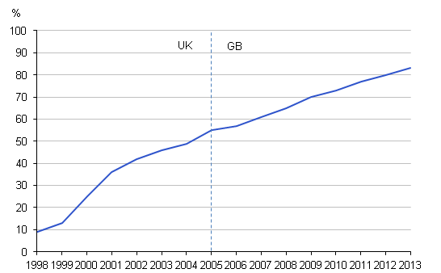

Figure 1: (Office for National Statistics, 2013)

## **1.1 THE OPPORTUNITY**

This hypertension telemedicine platform is specifically designed to give extensive care for patients within Manchester. Blood pressure monitoring with online consultations through linked devices with customized treatments targeting specific difficulties as well as simple accessibility are deemed as key factors of this service.

**TELEMEDICINE PLATFORM:** This platform is built-up on advanced technology to provide an extensive answer to all hypertension problems. It would include video consultation service, electronic healthcare records with AI generated analytics that guarantee personalized and effective care. (Steel & Wotton, 1997)

**VALUE PROPOSITION**

| **Convenience** | Rather than opting for hospital visits, individuals would be given medical consultations and undergo care from their own homes. This has a positive outcome as it may save time for individuals living in distant locations or have mobility issues. (Limbert, 2021) |
| --- | --- |
| **Continuous Monitoring** | Such a system includes blood pressure monitoring which helps in collection of real-time data. This monitoring allows for timely interference with modifications to medical programs, hence showing improvements in overall hypertension control. (Kuller, 2021) |
| **Personalized Treatment Plans** | Adopting AI-generated analytics, it suggests customized treatment options based on specific patient’s information. Each patient’s healthcare is customized to their specific health demands using this specific method. |
| **Expanded Accessibility** | This platform is available to doctors regardless of their geographical locations, making ascertain that individuals receive professional attention whenever required. This serves as proper management of chronic disorders. (Bashshur et al., 2000) |

***TABLE 01***

## **1.2 DESCRIPTION OF BUSINESS**

In order to guarantee that this service is accessible to everyone, it would be offered via a consumer friendly mobile application with an online platform. It entails initial registration, continual tracking device integration, counseling schedules with follow-up treatments. Individuals may gain rapid bookings, communicate their health information and obtain any medications digitally.

**SERVICE DELIVERY:** The platform would be designed in a way that both doctors and patients may use it without any complications. Patients can sign up on websites, integrate their blood pressure monitors, then arrange meetings with medical officers. The application would facilitate real-time exchange of data, ensuring that consultants are acquiring a patient's medical record with personal information during consultation. Furthermore, this platform would give follow-up care, guarantee ongoing assistance with surveillance. (May & Harrison, 2003)

**REVENUE MODEL:**

| **Subscription Cost** | Patients could acquire per-month, 6-months or yearly memberships. It would entail all time monitoring and consultation accessibility. Subscription model guarantees constantin-coming of revenues |
| --- | --- |
| **Per-Consultation Cost** | In case membership cost is considered inconvenient for patients, this platform would also introduce alternative charges per consultation. It is appropriate for people who need occasional consultation but not continuous screening. (Cheng, 2013) |
| **Collaborations** | For service expansion and delivery of integrated care solutions, we will partner up with both local medical professionals and insurance. These would result in generating additional income gains via cooperative ventures. |

***TABLE 02***

## **1.3 COMPETITIVE ADVANTAGE**

### **UNIQUE SELLING PROPOSITION**

The unique selling proposition of this platform is that it integrates accessibility, technological integration with data securities in order to give best services. Unlike conventional health care models, this telemedicine platform’s advanced technology would enable us to provide real-time personalized healthcare to hypertensive individuals. This system is consumer-friendly, enabling patients to gain access to healthcare without physical limitations, specifically for treating chronic disorders like hypertension. For patients, regular check-ups are a prerequisite so this function is important for its user-friendly layout. (Sterling & Reloug, 2019)

We maintain elevated levels of patient’s data privacy and security via strong encryption and adherence to healthcare legislation. Protection of patient data is our main concern, hence our advanced technology is also built-up for greatest standards of data security. Such dedication to security measures establishes confidence among both medical professionals and patients, making sure that confidential information is safeguarded. Integrating such features would result in distinguishment of this platform from traditional healthcare models, providing a reliable choice for hypertension management. (Lilly, 2019)

The industry at present is highly competitive with rivals like Teladoc Health, Doctor on Demand etc. They also offer services like online consultations and remote screening, what sets Hypercare apart is its priority for hypertensive patients, adopting advanced technology for real-time screening and personalized remedial measures. (Tulu & Forducey, 2010)

## **1.4 CANVAS BUSINESS MODEL** (Cheng, 2013)

The business model is detailed below:

| **Customer Segmentation** | * Hypertension individuals of manchester age group 30-70 * Tech-Savvy people opting for technologically advanced medical care. * Elderly patients in need of constant monitoring * People suffering from chronic diseases. |
| --- | --- |
| **Value Propositions** | * Virtual consultations could be taken from the comfort of home. * Constant screening of blood pressure by utilizing real-time data * Elevated level of data securities with privacy. |
| **Channels** | * Mobile applications on android and iphones. * Online websites * Collaborations with local medical professionals and insurance companies. |
| **Customer Relations** | * Personalized treatment using AI driven analytics with continuous screening. * Models based on subscription basis for all the service availability. * Regular reminders with follow-ups given to consumers. |
| **Revenue Streams** | * There would be monthly, 6-months and annual subscription fees. * Availability of per-consultation charges for individuals opting for no subscription. * Collaborations with local medical professionals and insurance companies. |
| **Key Sources** | * Teleheath Consultants and professionals * Advanced technological framework. * Marketing with customer service teammates. |
| **Key Activities** | * Establishment and maintenance of telemedicine platforms. * Giving customer support with service provisions. * Outreach initiatives and marketing. |
| **Key Partnerships** | * NHS with other health institutions. * Insurance Companies. * Local healthcare professionals. |
| **Cost Structure** | * Salaries for both healthcare professionals and supporting staff. * Data securities with compliance expenses. * Operational costs. |

**TABLE 03: (Kimble, 2015)**

# **INDUSTRY ANALYSIS**

The global telemedicine industry is presently increasing rapidly, driven by technological developments with increasing medical demand. The United Kingdom operates on a regulatory support system with financing for telehealth activities within place, establishing a climate conducive to telemedicine utilizations. (Fahmi, 2022). The NHS (National Health Service) has promoted digital health approaches, representing the increasing acceptability with usefulness of these telemedicine platforms. (Suman, 2021). Manchester’s health industry has inclusion of various medical professionals, both private and public. Main focus is on improving patient outcomes while simultaneously reducing medical expenses, making telemedicine an exciting choice. In addition, there is a strong integration of internet connectivity within the local population, along with increasing use of smartphones, this further facilitates utilization of healthcare services. (iris.paho.org, 2016)

## **2.1 MACROANALYSIS**

For this, we use Pestle Analysis (Gupta, 2014)

**PESTLE ANALYSIS**

1. **Political:** The Government of the UK supports telemedicine initiatives with legislative structures as well as financial resources. The NHS has given its due support to various digital healthcare remedies, showing political commitment towards telehealth breakthroughs. (Božić, 2023)
2. **Economic:** The main purpose of expansion of telemedicine is to reduce medical expenditures with improvements in patient’s health. (Messineo, 2024) This platform would serve as a financially reliab;e alternative as health-care technological investments expand.
3. **Social:** Both patients and doctors alike are using digital health solutions a lot. This increased longevity of populace with developments in chronic illnesses like elevated blood pressure establishes a requirement for constant screening with timely interference. (Fu, 2022)
4. **Technological:** When it comes to advanced technology, integration of AI and IoT along with other technical breakthroughs have facilitated the integration of telemedicine. (The World Bank, 2023). This one strategic measure has boosted telemedicine services because most smartphone users within urban areas like Manchester, United Kingdom have good internet connectivity.
5. **Legal:** The platforms pertaining to Telemedicine have to comply with GDPR ( Data Protection Legislations and Medical Regulations). Such a regulatory atmosphere has been converted towards more assistance for digital health technological measures, as law and regulation has been amended in response.
6. **Environmental:** Telemedicine would require less traveling, this results in deduction of carbon impacts of medical visits. This better aligns with bigger environmental patterns. Patients would get consultancy from the comfort of their own homes.

## **2.2 MICROANALYSIS**

For this analysis, we use Porter’s five forces.

1. **Threat of New Entrants:** Many new entrants could be drawn towards this telemedicine sector. Main reason is it’s zero to none entry barriers and increasing demand lately. (IBIS World, 2024).However, some barriers could be considered here like substantial initial costs with adherence to medical rules and regulations.
2. **Bargaining Power of Suppliers:** Suppliers may have standardized bargaining leverage, specifically for advanced technology like AI applications with Internet of Things gadgets. This could be pertaining to an increase in supplier populations with improvements in technology which enable choices like minimization of over-dependability on sole source. (Maresova, 2014)
3. **Bargaining Power of Buyers:** Many healthcare professionals have substantial negotiating power within telemedicine owing to varieties of available choices. Our main purpose is to attract and maintain customers by giving them reduced prices with innovative features like integration of AI.
4. **Threat of Substitute Products:** Main substitutes considered here are face-to-fac consultations with normal telehealth services. However, this danger is removed by enhanced demand for convenience, along with constant monitoring being offered by advanced technologies.
5. **Industrial Rivalry:** This industry is highly competitive as of lately, containing both new and well established firms. Gaining a competitive advantage entails differentiation via tech integration, low ricing with partnerships with medical professionals. (Pilipová, 2021)

## **2.3 COMPETITOR ANALYSIS**

Main competitors presently for Hypercare are Teladoc Health, Doctor on Demand as well as Amwell. The teladoc Health specializes in giving basic consultancy features pertaining to telemedicine. (health.ec.europa.eu, 2013). The Doctor on Demand has specialization in chronic disease management but it lacks AI Integration. Amwell has integration of AI and is a proficient telemedicine business but its pricing is so high, many people are unable to afford it.

| **Feature** | **Our Platform (HyperCare)** | **Teladoc Health** | **Doctor on Demand** | **Amwell** |
| --- | --- | --- | --- | --- |
| **AI-Driven diagnostics** | Yes | No | No | Yes |
| **Continuous Screening** | Yes | No | Yes | Yes |
| **Pricing** | Competitive | Lower | Similar | Higher |
| **Data Security** | High | Moderate | High | HIgh |

One rival Teladoc Health serves as a significant supplier in telemedicine industry services, these services are mostly consultation services. In spite of providing an extensive range of telehealth services, there is absence of numerous cutting-edge technologies like Ai-integrated diagnosis with continuous screening of employee's health, specifically high blood pressure. (Yadav, 2022). Although Teladoc has numerous subscribers because of reduced unit rates, nonetheless, many customers have viewed intermediate data safety standards as adverse when it comes to data protection.

The doctor on Demand website has a main emphasis on chronic disease management. This website is considered a direct rival in regards to the target marketplace. However, there is a lack of AI for diagnostic purposes, putting restrictions on its capability to provide customized as well as predictive medical remedies. Also, its pricing is quite similar to ours, but it provides elevated levels of security. This makes it proficient but not very advanced pertaining to technology.

Our third competitor is Amwell. Its complete Telehealth remedies offer advanced features like AI-driven diagnostics at more expensive prices when compared to us. This platform also has similar technological capabilities with data protection aspects towards our platform.Nevertheless, such techniques could limit accessibility, as the expenses would remain modest resulting in more consumers being able to afford it. (Blix & Jeannson, 2018). HyperCare is unique from others by offering technologically adapted services at affordable prices while assuring data protection. It guarantees any information would be kept confidential. Such a mix of features fills gaps within rival solutions, developing us as the most proficient alternative for medical professionals managing hypertension within Manchester. (Young & Han, 2003)

# **3. MARKET ANALYSIS**

**3.1 TARGET MARKET**

**Demographics**

The age varies in adults between 30s to early 70s. These people have more likelihood to develop hypertension, so they may get more advantage from continual screening with urgent medical care. People living in Manchester would have accessibility to this application. Focus on a single location would result in adjustments of our services towards local health-care infrastructures with a regulatory environment. When considering health conditions, the main target is hypertensive patients. This class includes people who are diagnosed with increased blood pressure and require constant care with frequent check-ups for avoidance of any problem.

**Psychographics**

We have targeted health conscious individuals whose main concern is regarding their own health, how to improve it. These people are always looking for proficient remedies to control their conditions before it gets worse, this works in our favor too. Such individuals are also tech savvy. They can utilize technologies for healthcare purposes. These technologies can be used in the form of mobile applications with internet platforms. Lastly, such patients are always in search of convenient Health Care solutions, so these types of healthcares work perfectly fine for them. They are able to fit busy schedules with consultation schedules, avoiding visitation on a constant basis.

**CUSTOMER SEGMENTATION TOOLS**

Numerous tools have been utilized by us with concepts regarding identification and categorization of target markets. Developing unique user personas serves as one method for comprehending the unique requirements with preferences of different sectors of our targeted market. (le Roux, 2023). For instance, we ought to create personas for middle-aged people who want to balance out work and health along with retired people showing more concern for their health. Surveys with potential users within Manchester ought to give useful insights into their healthcare requirements, technological use with telemedicine service choice. (housinglin.org.uk, 2022)

## **3.2 MARKET SIZE**

The market size can be calculated by the total number of potential customers of our telemedicine within a specific marketplace along with total income which ought to be produced by these sales. In our research, we would concentrate on specific population of United Kingdom i.e. Manchester city. Here, it is expected to reach approximately 550000 by the end of the year 2024. (Market Publishers, 2024). The population breakdown is given as follows:

Tech-savvy People: Primarily aged around 16-45. Rough approximation is 30% of total population, this means 165,000 individuals in total.

Old-aged People: They make around 15% of the population, this makes 82,500 people.

People suffering from Chronic Disease: Total 20% in population. This totals 110,000 individuals.

Assuming there is market penetration of 10% within the first year, then potential customer base would be around 16,500 people who are tech-savvy, 8,250 people who are elderly patients with 11,000 people being chronic disease sufferers.

**SALES FORECAST FOR 1 YEAR**

The consumer expenditures on healthcare in the United Kingdom are seen to be increasing significantly, with estimations putting it at around 8 billion pounds. Despite a minor decrease from 2021 to 2022, all the trend points towards effective demand for healthcare services which includes telemedicine as well. The average annual spending of customers is distributed as £200 for tech-savvy people, £500 for all elderly patients and lastly, £400 for chronic disease sufferers. Utilizing this, our total revenue for year 1 can be calculated.

| **Consumer Segmentation** | **Potential Clients** | **Average Annual Spending** | **Total Revenue** |
| --- | --- | --- | --- |
| Tech-savvy people | 16,500 | 200 | 3,300,000 |
| Elderly patients | 8,250 | 500 | 4,125,000 |
| Chronic Disease sufferers | 11,000 | 400 | 4,400,000 |

This makes revenues for year 1 accounting at £11,825,000.

**MAIN ASSUMPTIONS**

* First of all, we have assumed a 10% penetration rate within the initial year. This has been indicated in our delayed entry to marketplace strategy.
* Secondly, there will be demand for personalized and online health remedies which must be stable. This is because individuals are more drawn towards telemedicine for its ease with efficacy.
* Thirdly, expense estimates on a yearly basis per patient were established from market study with experience within similar telemedicine services with healthcare delivery systems which are readily available within the market.

The assumptions given above form the basis for our sales projections in this year. This shows considerable income potential of our telehealth platform within manchester. The targeting of tech-savvy people, elderly people with those suffering from chronic disease could end up with a broad community only concerned with the well-being of people. This results in longevity of market reach.

## **3.3 MARKETING PLAN**

7 P’s are given blow: (Guide, 2021)

| **Product** | This telemedicine technology made specially for hypertension individuals gives AI-driven diagnoses, continuous monitoring with safe data storage choices. There will be an online platform (Application) available for this purpose. Main features are:   * Advanced Technological systems analyzing health data for prediction of potential patterns with practical recommendations. * Fully secure video calls with medical professionals. * Resources present for patient education tools. |
| --- | --- |
| **Price** | The pricing serves as a strong feature as it gives different subscription choices. These are:   * Basic Plan: This entails monitoring with consultation components. * Premium Plan: This entails advanced analytics, personalized health insights with priority accessibility to specialists. * Enterprise Plan: This one is for health providers in want of large subscriptions with integration of already present medical systems. |
| **Place** | This platform is available through online mobile applications on any device. This allows patients and healthcare professionals to access its service from anywhere they want. Main objective is that users have a positive experience whilst using this system without interruptions. |
| **Promotion** | Our marketing plan would include:   * Digital Marketing: Such a strategy is used for social media networks, SEO- search engine optimization and PPC-pay per click. Main purpose is to attract internet-savvy people along with doctors who prefer technological integration into healthcare. * Collaboration: This means working closely with local health officials like hospitals, clinic for promotion of this platform by incorporation of its services into them. * Professional Conferences: There will also be participation in conferences or medical fairs arranged within Manchester to demonstrate our platform to all audiences present. |
| **People** | Our team would include experienced medical professionals, IT specialists with support staff members who receive ongoing training in order to provide exceptional services. |
| **Process** | In order to guarantee the effectiveness with integrity, we have simplified our processes:   * Enrollment: Both patients and doctors can easily sign up and be a member. * User assistance: There would be a special support team ready for assisting clients 2 hours, 7 days a week. * Input Loop: We will collect user inputs on regular intervals, examine it and use it for enhancement of the platform. |
| **Physical Evidence** | The demonstration would be done as follows:   * Case Studies: documenting and sharing patient’s success encounters for establishment of credibility. * Testimonials: collecting testimonials from satisfied clients and doctors. * Demonstrations: This would be given to potential customers so they made a firsthand encounter of how the platform works actually. |

## **3.4 SALE FORECAST**

|  | **YEAR 1** | **YEAR 2** | **YEAR 3** | **YEAR 4** | **YEAR 5** |
| --- | --- | --- | --- | --- | --- |
| Total Users | 10,000 | 15,000 | 20,000 | 25,000 | 30,000 |
| Subscription Revenue | GBP 600,000 | GBP 900,000 | 1200,000 | 15,00000 | 1,800,000 |
| Consultation Revenue | GBP 400,000 | GBP 600,000 | GBP 800,000 | 1000000 | 1,200,000 |
| Total Revenue | GBP 1000,000 | GBP 1500,000 | GBP 2000,000 | 25,00,000 | 3,000,000 |

The alignment of the sales forecast with cash flow projections guarantees this platform remains financially viable while increasing in terms of productivity.

# **4. OPERATIONS PLAN**

## **4.1 SERVICE PROCESS**

We have a telemedicine platform within Manchester for treatment of patients with high blood pressure. This platform provides extensive health care via a streamlined service process. The service methods would include following factor:

**Initial consultation**: This entails physicians assessing the patients in order to determine how they are doing, assess their medical history and then develop individualized treatment structures. This ought to be accomplished via video calls, telephone conversations as well as encrypted text messages. (Providence.org, 2021)

**Constant Monitoring:** By utilization of device assistance, patients who got their initial consultancy would have blood pressure and heart rate screened too. The real-time data transmission from these gadgets into our framework would help out in trackin patient’s health state while providing effective medical attention.

In order to assess any patient’s progress when therapy starts, amendments in treatment plan if deemed necessary should be done while giving assistance as needed, regular follow-up consultations may also be required. In our care plan, there might be incorporation of remote consultations, prescription refills with referrals to experts.

Our administrative headquarters would be located within Manchester, where they function as central to all the activities. This office would incorporate administration along with IT support teams. The healthcare workers would be working on a remote basis in order to give a flexible and accessible system towards both patients and staff members.

## **4.2 STAFFING**

The operational team is given as follows:

In order to ascertain the success of our service delivery, our team members would be in various positions, each important to maintain both quality with efficiencies of our telemedicine platforms. The healthcare professionals would incorporate nurses, physicians with hypertension experts. With addition of consultations, these specialists would screen out an individual's health and simultaneously offer constant care and support. (Foster, 2006)

There would be recruitment of IT specialists too. The IT support specialists would include developers, data analysts with technical assistance specialists. This set of people would manage the platform’s overall infrastructure, give protection of data security with provision of technical assistance to patients and healthcare providers alike.

There will also be the presence of an administrative team. These would include customer service agents, billing officers along with operations managers. This administrative department would be managing patient queries, processing of payments and overseeing day-to-day operations of the administrative office.

In order to meet our operational requirements, there would be segmentation of staff members in following way:

Doctors: 5 practitioners having experience in dealing with hypertension patients.

Nurses: 10 nurses for constant patient screening with follow-up care.

Specialists: 3 for advanced consultation purposes

IT Developers: 8 Developers for maintaining and upgrading the Platform as per new trends.

Data Analysts: 2 individuals for interpretation of patient’s data and generating health reports

Tech Assistance: 2 individuals who are readily available for any technical issue.

Customer Service Representative: For dealing with customer complaints etc.

Billing Staff: Management of payments.

Operations Manager: 2 for overseeing all operations run smoothly.

## **4.3 TECHNOLOGY AND INFRASTRUCTURE**

To provide high-quality services, our telemedicine platform is built on reliable technology and infrastructure. Key components are:

In order to provide high-quality services , these telemedicine platforms would be developed on reliable technologies along with infrastructures. Main essential parts would include cloud-based systems. In our system, there would be scalable cloud architecture that would make high accessibility with performance a complete guarantee. Then there would be incorporation of real-time data transmission. For this, constant monitoring gadgets would provide patient data within real time, further enabling for prompt assessment and if required taking action. Lastly, as an intuitive, customer-friendly framework would allow for quick accessibility to healthcare providers, appointments scheduling with communication choices.

**Security Measures:** Most important framework within our operations is data security. In order to secure a patient's personal information, we have implemented quite a few elements. These include encryption first of all. Each data must be encrypted amidst transit as well as at rest. There would be strict accessibility restrictions guaranteed which only authorized individuals having access to confidential data. Next, there would be compliance to GDPR as well as any applicable data protecting requirements.

**Healthcare Regulations:** Our activities follow all applicable healthcare legislation and telemedicine guidelines established by the National Health Service (NHS) and other regulatory agencies. Key aspects of compliance are: Our actions would be following the applicable healthcare legislation with telemedicine guidance being developed by NHS (National Health Service) along with other regulatory agencies. Main aspects of such compliance include patient permission. First of all, gaining consent from patients for these services is considered necessary. Then there are clinical standards. Compliance with these clinical norms would include practices for hypertension care. Main recommendations for telemedicine are remote meetings, data privacy and information confidentiality.

**Insurance and Liability:** we acquire sufficient insurance coverage to safeguard both our patients and employees alike.

* Professional Liability Insurance would safeguard healthcare professionals against any negligence charges.
* Cyber Liability Insurance would safeguard against any data breaching or cyber attacks.
* General Liability Insurance would cover all administrative as well as operational risks.

## **4.4 SCALABILITY STRATEGIES**

There has been sufficient demand for telemedicine as of lately. In order to meet growing demand, we have implemented some scalability strategic measures. (Edwards, 2014)

**Expansion of Medical Professional Networking:** Constant recruitments of more medical professionals in order to fulfill patient demand. This expansion would give timely and proficient care to an expanding number of clients.

**Improvements in IT Facilities:** Doin investments in updating servers, increasing data storage capacities as well as improving the platform’s consumer interface for handling of patients would be deemed adequate. There would also be sufficient maintenance of operations. (Kwolek, 2008)

**Increasing Service Offerings:** In order to attract a large consumer base, we have considered offering more telemedicine services like mental health assisting with chronic illness management.

**Regular Training Sessions:** In order to guarantee that our workforce would receive high-quality treatments we will implement regular training programs. These would cover the most recent advancements within hypertension care and data security norms. Also, we would execute quality assurance processes for monitoring and assessing how our services are being performed. (Milburn, 2012)

## **4.5 SOCIAL MEDIA PLATFORMS**

We would be utilizing social media platforms in order to expand our reachability and engage patients. These platforms would have the usage of educating patients i.e. provide them necessary hypertension management informations, healthy living ways with service upgrades. Also engaging the community is another aspect. We would establish a feeling of community by making connections with patients, giving answers to their questions while addressing their issues. Lastly, there would be promotion of our services. We would make emphasis on our telemedicine platform while simultaneously urging everyone to use this application.

We would be adopting certain social media platforms like:

Facebook would be utilized for community involvement, sharing of articles with promotional events. Twitter for all latest updates, healthcare counseling and any consumer service inquiries.

Instagram has a main purpose in showcasing visual content i.e. patient testimonies with behind the scene short videos in form of reels and posts. Linkedin being an app for professional communications would be utilized for this same purpose.There would be exchange of industrial information with recruitments of medical professionals.

**ALLIANCE WITH CASH FLOW FORECAST**

The operations strategy would be well aligned as per our cash flow predictions, making guarantee that we establish and maintain all of our services over time. The income generation via patient subscriptions along with consultations ought to be reinvested in order to expand our healthcare professional networks, improvements in IT structures with maintenance of servicing quality. The careful management of resources with assessment of financial evaluations would result in assurement of longevity in stability with profitability of telemedicine platforms.

# **5. COSTINGS**

Assessment along with budgeting of both fixed and variable costs is deemed essential for smooth running of our telemedicine platforms. (Zocchi, 2020). Both these costs have been depicted in the tables below with monthly plus yearly computations.

## **5.1 Fixed Costs**

| **Cost Segmentation** | **Annual Costs** |
| --- | --- |
| Technology Platform | £100,000 |
| Staff Salaries | £300,000 |
| Marketing | £50,000 |
| Office Space | £50,000 |
| Miscellaneous | £20,000 |
| Total Fixed Costs | £520,000 |

## **5.2 Variable Costs**

| **Cost Segmentation** | **Monthly Costs** | **Annual Costs** |
| --- | --- | --- |
| Technology Platform | £10,000 | £120,000 |
| Staff Salaries | £25,000 | £300,000 |
| Marketing | £5,000 | £60,000 |
| Office Space (Utilities, Supplies) | £2,000 | £24,000 |
| Miscellaneous | £1,000 | £12,000 |
| Total Variable Costs | £43,000 | £516,000 |

Combined Cost would be as given:

| **Type of Cost** | **Annual Costs** |
| --- | --- |
| Fixed Costs | £520,000 |
| Variable Costs | £516,000 |
| Total Costs | £1,036,000 |

## **5.3 UNIT COSTINGS**

| **Expenses** | **Cost per Consultation** | **Monthly Cost** |
| --- | --- | --- |
| Technology | £5 | £10,000 |
| Staff | £10 | £20,000 |
| Administration | £2 | £4,000 |
| Total Cost per Consultation | £17 | £34,000 |

Let's assume there is an average of about 2000 consultations each month, then monthly unit costs are given as above. The yearly metrics are depicted as:

| **Metrics** | **Value** |
| --- | --- |
| Consultations each Month | 2,000 |
| Expenses per consultation | £17 |
| Yearly total costs | £408,000 |

**Sources of Finance:**

| **Source of Finance** | **Amount GBP** | **Percentage** |
| --- | --- | --- |
| Personal Savings | 200,000 | 20% |
| Bank Loan | 300,000 | 30% |
| Angel Investors | 250,000 | 25% |
| Government Grants | 150,000 | 15% |
| Crowdfunding | 100,000 | 10% |
| **Total** | **1000,000** | **100%** |

**MAIN ASSUMPTIONS**

First main assumption we discuss here is technological expenses. We have expected that technological costs are going to be steady with small incremental changes. These changes would be positive. Constant maintenance with updates have to be included within both fixed and variable costs in order to keep this platform working. (Atmojo, 2024)

Next major assumption pertains to staffing. Our staffing would be based upon present forecasts and is also enough for handling expected user populace. We believe that our team of experts, IT specialists along with administrative personnel would be quite sufficient for the initial year. When this system expands, we would modify the worker level to guarantee good service quality.

Next we have assumptions of market conditions. (Handerson, 2013) We have anticipated that elevated demand regarding telemedicine services would be driven by increasing rates of hypertension with expansion of adoptions in digital health remedies. Initiatives pertaining to marketing have been anticipated to increase awareness with utilization within targeted marketplace. (Reardon, 2005)

We have predictions that there would not be any major modifications within regulatory requirements which might impact the operations or our structure of costs. We foresee a regulatory environment. The cost analysis has taken us into account compliances with present healthcare standards along with data protection legislations.

There are economic factors that need to be taken into account. We have expected that the current economic situation is remaining stable without any significant inflationary measures or economic downturns which might impact our overall expenses structure with client spending.

The technological built-up we have introduced is designed specifically to be scalable. This allows for us to expand the overall customer base with reduction in any enormous per unit costs. Doing technological investments with manpower serve as scalable for accommodation of any elevated number of consultations.

The projections of revenues have been coordinated with cost assessment with a basis on research in the marketplace along with predictions in adoption rates, giving assurement of financial sustainability with potential in expansion. Comprehending and executing such major assumptions would ensure that the telemedicine structure is effective and financially viable. Such extensive assortment of cost effectiveness would serve as an effective basis for strategic decision making with plannings for a long time basis.

# **FINANCIALS**

In general, a financial plan is a thorough assessment of an individual's present pay and future financial situation that uses current known variables to forecast future income, asset values, and withdrawal strategies. (Home.csulb.edu, 2022) A financial plan can assist in identifying whether decisions will have an influence on income and whether occasions need the use of reserve money. It's also useful when requesting investors to evaluate your business. The financial plan demonstrates how the organization controls expenditures and produces money. (FAS, 2018)

## **6.1 CAPITAL AND FINANCE SOURCES**

For this, the whole first cash required would be development of telemedicine platforms is GBP 50,000. Such funding would be required for paying technological setups. These would be approximately £100,000, with employees salaries standing at £300,000 as well as marketing £50,000. With this, there would be finances for office space £50,000. Miscellaneous costs would entail £20,000. These are critical for ensurement of platform which is properly equipped as well as advertised in order to reach the target marketplace.

**POTENTIAL FINANCE SOURCES**

**Loans:** Acquiring a business loan from any bank or financial institution would entail getting initial fundings whilst allowing us to get business ownership. In accordance with cash flow estimations,interest rates as well as payback periods would have to be arranged.

**Equity Investors:** Getting attention of equity investors who have strong beliefs in our busines’’s ideas and developing potential could give sufficient money. With exchange of funds, investors would be getting stock holdings within any business.

**Healthcare Grants:** Applications for grants being created expressly to assist online healthcare activities and telemedicine could result in non-diluting finances. Such funds have been frequently offered from government agencies as well as healthcare entities.

## **6.2 PAYBACK WITH EXIT STRATEGY**

On the basis of our assumptions pertaining to income and expenses, we have predicted a payback period of approximately three years. Such an estimate would take into account the initial financial requirements along with growth in revenue . This would occur with increase in user adoption and consultation volumes.

For ensuring of proper exit strategy, two approaches have been given as:

**Acquisition:** For a profitable exit-strategy, this business could be sold to a firm having a larger healthcare system or online health-focused technological corporation. This would result in a profitable exit strategy. Such an option would allow for acquirers to get benefits from already developed platforms along with the customer base.

**Public Offering:** Making the business go public via IPO (Initial Public Offering) could result in immense benefits and elevated awareness in markets. Such a method is viable only when business may prove itself to be financially stable.

## **6.3 FORECASTED INCOME STATEMENT**

For year 1:

| **Item** | **Total Amount** |
| --- | --- |
| Total Revenue | 1,260,000 |
| Cost of Goods Sold | 720,000 |
| Gross Profit | 540,000 |
| Operating Expenses | 400,000 |
| Net Profit | 140,000 |

For the next four years:

| **Year** | **Total Revenue** | **Cost of Sold Good** | **Gross Profit** | **Operating Expenses** | **Net Profit** |
| --- | --- | --- | --- | --- | --- |
| Year 2 | 1,890,000 | 1,080,000 | 810,000 | 500,000 | 310,000 |
| Year 3 | 2,520,000 | 1,440,000 | 1,080,000 | 600,000 | 480,000 |
| Year 4 | 3,150,000 | 1,800,000 | 1,350,000 | 700,000 | 650,000 |
| Year 5 | 3,780,000 | 2,160,000 | 1,620,000 | 800,000 | 820,000 |

## **6.4 CRITICAL RISK FACTORS**

Identification and mitigation of critical risk factors is considered important for successfulness of our telemedicine platforms:

* **Regulatory Changes:** Major changes within healthcare regulations ought to affect the operations of this business. We would have to stay updated on regulatory developments while making guarantees of compliance.
* **Data Security:** Any breach within our security systems would result in reputational damage for us, consequently legal consequences. We would have to make investments in good cybersecurity practices.
* **Market Competition:** Our market dynamics could be influenced by increased competitiveness. We would constantly innovate while enhancing our platform in order to have competitive advantage.
* **Financial Risks:** Many major fluctuations in the context of funding availability with economic factors could affect our financial stability. Diversification of sources of funds whilst maintenance of effective cash reserves would result in risk mitigation.

# **REFERENCES**

1. Atmojo, J. T. (2024, January 12). *(PDF) Telemedicine, Cost Effectiveness, and Patients Satisfaction: A Systematic Review*. ResearchGate. Retrieved June 24, 2024, from https://www.researchgate.net/publication/343298714_Telemedicine_Cost_Effectiveness_and_Patients_Satisfaction_A_Systematic_Review
2. Bashshur, R., Geardon, T., & Shannon, G. w. (2000). Telemedicine: A New Health Care Delivery System. *ANNUAL REVIEW OF PUBLIC HEALTH*, *21*, 613-637. https://doi.org/10.1146/annurev.publhealth.21.1.613
3. Blix, M., & Jeannson, J. (2018). *Telemedicine and the Welfare State: The Swedish Experience*. https://www.ifn.se/media/3adc1ks3/wp1238.pdf
4. Božić, V. (2023, July 7). *(PDF) Objectifying SWOT and PESTLE Analysis in Hospital*. ResearchGate. Retrieved June 24, 2024, from https://www.researchgate.net/publication/372166219_Objectifying_SWOT_and_PESTLE_Analysis_in_Hospital
5. Cheng, A. (2013). *(PDF) A Review of Telemedicine Business Models*. ResearchGate. Retrieved June 24, 2024, from https://www.researchgate.net/publication/236091643_A_Review_of_Telemedicine_Business_Models
6. Cheng, A. (2013). *A Review of Telemedicine Business Models*. https://www.liebertpub.com/doi/abs/10.1089/tmj.2012.0172
7. Debnath, D. (2004, June 10). Activity analysis of telemedicine in the UK. *Postgraduate Medical Journal*, *80*(944), 335-338. https://doi.org/10.1136/pgmj.2003.015453
8. Edwards, M. (2014). *Roadmap for Planning Development of Telehealth Services*. Northeast Telehealth Resource Center. Retrieved June 24, 2024, from https://netrc.org/wp-content/uploads/2015/04/NETRC-Roadmap-for-Planning-Development-of-Clinical-Telemedicine-Services-2014.pdf
9. Fahmi, I. (2022). *New Normal Analysis of Telemedicine-Based Healthcare Industry*. https://ijshr.com/IJSHR_Vol.7_Issue.3_July2022/IJSHR14.pdf
10. FAS. (2018). *An Introduction to Financial Planning*. Financial Advice & Services. Retrieved June 24, 2024, from https://financial-advice.co.uk/guides/Financial-Planning.pdf
11. Foster, M. A. (2006, March). *TELEHEALTH BUSINESS MODELS*. https://scholarworks.alaska.edu/bitstream/handle/11122/12237/TelehealthReport1b.pdf?sequence=1&isAllowed=y
12. Fu, A. (2022). *The Impact of Telemedicine and Virtual Software on the Healthcare Industry during COVID-19 Based on SWOT, PEST & BCG Matrix Analysis*. https://eudl.eu/pdf/10.4108/eai.18-11-2022.2326949
13. Guide, S. (2021). *Telehealth Marketing Plan Development*. California Telehealth Resource Center. Retrieved June 24, 2024, from https://caltrc.org/wp-content/uploads/2021/02/CTRC_MarketingPlanGuide_2021LayoutPatients_FINAL-1.pdf
14. Gupta, R. (2014). *Telemedicine: A brief analysis*. https://www.researchgate.net/publication/277924225_Telemedicine_A_brief_analysis
15. Handerson, C. (2013). *26 Unit Costs of Health and Social Care 2013 - The costs of telecare and telehealth*. PSSRU. Retrieved June 24, 2024, from https://www.pssru.ac.uk/pub/uc/uc2013/henderson-beecham-knapp.pdf
16. health.ec.europa.eu. (2013). *Market study on telemedicine*. Public Health. Retrieved June 24, 2024, from https://health.ec.europa.eu/system/files/2019-08/2018_provision_marketstudy_telemedicine_en_0.pdf
17. Home.csulb.edu. (2022). *Introduction to Financial Statements*. CHAPTER 1 Introduction to Financial Statements Study Objectives 1. Describe the primary forms of business organization. 2. Ident. Retrieved June 24, 2024, from https://home.csulb.edu/~mdchase/StudyGuideChap01.pdf
18. housinglin.org.uk. (2022). *The evolving UK market for telecare*. Housing LIN. Retrieved June 24, 2024, from https://www.housinglin.org.uk/_assets/Resources/Housing/OtherOrganisation/Evolving_UK_market_for_telecare.pdf
19. IBIS World. (2024). *Telehealth Services in the UK - Market Size, Industry Analysis, Trends and Forecasts (2024-2029)*. IBISWorld. Retrieved June 24, 2024, from https://www.ibisworld.com/united-kingdom/market-research-reports/telehealth-services-industry/
20. iris.paho.org. (2016). *Framework for the Implementation of a Telemedicine Service*. Iris Paho. Retrieved June 24, 2024, from https://iris.paho.org/bitstream/handle/10665.2/28414/9789275119037_eng.pdf
21. Kimble, C. (2015). *Business Models for e-Health: Evidence from Ten Case Studies*. arXiv. Retrieved June 24, 2024, from https://arxiv.org/pdf/1507.00553
22. Kuller, D. (2021, April). *A Home Telemedicine System for Continuous Respiratory Monitoring*. https://ieeexplore.ieee.org/abstract/document/9151180
23. Kwolek, B. (2008). *Scalable Telemedicine Solutions-Research Direction of KCT*. https://www.researchgate.net/publication/228454525_Scalable_Telemedicine_Solutions-Research_Direction_of_KCT
24. le Roux, A. (2023). *(PDF) Telemedicine in the United Kingdom: From a patchwork of services and regulations to a connected health and e-health revolution*. ResearchGate. Retrieved June 24, 2024, from https://www.researchgate.net/publication/373604146_Telemedicine_in_the_United_Kingdom_From_a_patchwork_of_services_and_regulations_to_a_connected_health_and_e-health_revolution
25. Lilly, C. M. (2019). Evolution of the Intensive Care Unit Telemedicine Value Proposition. *Critical Care Clinics*, *35*(3), 463-477. https://doi.org/10.1016/j.ccc.2019.02.010
26. Limbert. (2021). Telemonitoring, Telemedicine and Time in Range During the Pandemic: Paradigm Change for Diabetes Risk Management in the Post-COVID Future. *Diabetes Ther*, *12*, 2289–2310. https://doi.org/10.1007/s13300-021-01114-x
27. Maresova, P. (2014, December 5). *PORTER'S FIVE FORCES ON MEDICAL DEVICE INDUSTRY IN EUROPE*. MMSL. Retrieved June 24, 2024, from https://mmsl.cz/pdfs/mms/2014/04/01.pdf
28. Market Publishers. (2024, March). *Telehealth and Telemedicine Market Size, Trends, Analysis, and Outlook By Type (Remote Patient Monitoring, Real Time Interaction, Store and Forward), By Offering (One-Time Purchase, Subscription Based, Pay-Per Use), By Hardware (Monitors, Medical Periphera*. https://pdf.marketpublishers.com/vpar/telehealth-n-telemedicine-market-size-trends-analysis-n-outlook-by-type-remote-patient-monitoring-real-time-interaction-store-n-forward-by-offering.pdf
29. May, C., & Harrison, R. (2003). Why do telemedicine systems fail to normalize as stable models of service delivery? *International Society for Medicine and ehealth*, *9*(1), 25-26. 10.1258/135763303322196222
30. Messineo, R. (2024, May 29). *Master PESTEL Analysis in Healthcare: What It Is & How to Conduct One Master PESTEL Analysis in Healthcare: What It Is & How to Conduct One*. ClearPoint Strategy. Retrieved June 24, 2024, from https://www.clearpointstrategy.com/blog/pest-analysis-healthcare
31. Milburn, J. (2012). *Delivering scalable Telehealth: ‘What is Scale?’ with case studies from NHS providers, a perspective on the challenges, constraints and issues associated with ‘scalability’*. <https://www.researchgate.net/publication/279913735_Delivering_scalable_Telehealth_'What_is_Scale'_with_case_studies_from_NHS_providers_a_perspective_on_the_challenges_constraints_and_issues_associated_with_'scalability>'
32. Minuz, P. (2023, August 18). *Telemedicine and Digital Medicine in the Clinical Management of Hypertension and Hypertension-Related Cardiovascular Diseases: A Position Paper of the Italian Society of Arterial Hypertension (SIIA)*. NCBI. Retrieved June 17, 2024, from <https://www.ncbi.nlm.nih.gov/pmc/articles/PMC10600275/>
33. Montgomery, K. (2019). *Development of a Tele-Healthcare Clinical Practice Guideline for Diabetic Patients*. <https://scholarworks.waldenu.edu/dissertations/7702/>
34. Nicholas, K. (2023). *Report template*. eWIN. Retrieved June 17, 2024, from <https://www.ewin.nhs.uk/sites/default/files/Telemedicine%20.pdf>
35. Nickelson. (1998). Telemedicine and Evolving Healthcare Sytem. *Professional Psychology: Research and Practice*, *29*(6), 527–535. <https://doi.org/10.1037/0735-7028.29.6.527>
36. Ohinmaa, A. (2008). *The effectiveness of telemental health applications: a review*. PubMed. Retrieved June 17, 2024, from <https://pubmed.ncbi.nlm.nih.gov/19087471/>
37. Office for National Statistics. (2013, August 8). *Internet access - households and individuals, Great Britain*. Office for National Statistics. Retrieved June 23, 2024, from <https://www.ons.gov.uk/peoplepopulationandcommunity/householdcharacteristics/homeinternetandsocialmediausage/bulletins/internetaccesshouseholdsandindividuals/2013-08-08>
38. Omboni, S. (2022, June). *Telemedicine for hypertension management: where we stand, where we are headed*. <https://oaepublishstorage.blob.core.windows.net/7f370bba-86f7-4a8c-9733-a3969f9a34fb/4998.pdf>
39. One80. (2023). *Remote Patient Monitoring in Home Health Care Increasingly Popular*. <https://www.one80.com/news/remote-patient-monitoring-in-home-health-care-increasingly-popular/>
40. Pilipová, S. (2021). *STRATEGIC MARKETING PLAN FOR TELADOC HEALTH INC.* Anglo-American University. Retrieved June 24, 2024, from https://www.aauni.edu/wp-content/uploads/2022/05/sba-thesis-sylvie-pilipova.pdf
41. Providence.org. (2021). *Key Considerations in Operationalizing a Telehealth Program*. Providence. Retrieved June 24, 2024, from https://www.providence.org/-/media/project/psjh/providence/socal/files/telehealth/telehealthwhitepaper.pdf?rev=70e9743e73264aa0a0ef75e0d1f9e923&hash=7C30E21AD26023E38D14E51448C3E8BB
42. Reardon, T. (2005). Research Findings and Strategies for Assessing Telemedicine Costs. *TELEMEDICINE AND e-HEALTH*, *11*(3).
43. Robles, N., & Katz, C. (2022, October 27). *The Current Status of Telemedicine Technology Use Across the World Health Organization European Region: An Overview of Systematic Reviews*. Journal of Medical Internet Research. Retrieved June 23, 2024, from https://www.jmir.org/2022/10/e40877/
44. Smith, A. (2007, November 22). *How telemedicine helps*. https://www.bmj.com/content/335/7629/1060.1.short
45. Steel, K., & Wotton, R. (1997). *Primary care telemedicine in the UK.* https://www.ncbi.nlm.nih.gov/pmc/articles/PMC1312873/
46. Sterling, R., & Reloug, S. (2019). On-Demand Telemedicine as a Disruptive Health Technology: Qualitative Study Exploring Emerging Business Models and Strategies Among Early Adopter Organizations in the United States. *Journal of medical internet research*, *21*(11).
47. Suman, R. (2021). *Telemedicine for healthcare: Capabilities, features, barriers, and applications*. NCBI. Retrieved June 24, 2024, from <https://www.ncbi.nlm.nih.gov/pmc/articles/PMC8590973/>
48. Smith, A. C., & Gray, L. C. (2009, January 5). *Telemedicine across the ages*. The Medical Journal of Australia. Retrieved June 17, 2024, from <https://www.mja.com.au/journal/2009/190/1/telemedicine-across-ages>
49. Sood, S. (2007). *(PDF) What Is Telemedicine? A Collection of 104 Peer-Reviewed Perspectives and Theoretical Underpinnings*. ResearchGate. Retrieved June 17, 2024, from <https://www.researchgate.net/publication/5846578_What_Is_Telemedicine_A_Collection_of_104_Peer-Reviewed_Perspectives_and_Theoretical_Underpinnings>
50. Stanberry, B. (2006). *Legal and ethical aspects of telemedicine*. PubMed. Retrieved June 17, 2024, from <https://pubmed.ncbi.nlm.nih.gov/16774696/>
51. Talley, J. (2008). *Empirical evidence on the use and effectiveness of telepsychiatry via videoconferencing: implications for forensic and correctional psychiatry*. PubMed. Retrieved June 17, 2024, from https://pubmed.ncbi.nlm.nih.gov/18548519/
52. Tulu, B., & Forducey, P. (2010). The Business of Telemedicine: Strategy Primer. *Telemedicine and ehealth*, *16*(8). https://doi.org/10.1089/tmj.2009.0178
53. The World Bank. (2023). *Planning National Telemedicine and Health Hotline Services*. https://www.villagereach.org/wp-content/uploads/2023/02/9781464819551-Governments.pdf
54. Wotton, R. (1998). *Telemedicine in the National Health Service*. https://journals.sagepub.com/doi/abs/10.1177/014107689809101202
55. Wen, J. (2003). *The Evolving Face of TeleMedicine & E-Health: Opening Doors and Closing Gaps in E-Health Services Opportunities & Challenges.* <https://www.researchgate.net/publication/221184645_The_Evolving_Face_of_TeleMedicine_E-Health_Opening_Doors_and_Closing_Gaps_in_E-Health_Services_Opportunities_Challenges>
56. Wootton. (1996). *Telemedicine: a cautious welcome.* <https://www.ncbi.nlm.nih.gov/pmc/articles/PMC2352879/>
57. Wilson, N. (2009). *A critical review of Interventions to redress the inequitable distribution of healthcare professionals to rural and remote areas*. <https://www.researchgate.net/publication/326489113_A_critical_review_of_Interventions_to_redress_the_inequitable_distribution_of_healthcare_professionals_to_rural_and_remote_areas>
58. Yadav, S. (2022, August 30). *(PDF) Telemedicine and Its Role in Innovating the Provision of Healthcare*. ResearchGate. Retrieved June 24, 2024, from https://www.researchgate.net/publication/362890285_Telemedicine_and_Its_Role_in_Innovating_the_Provision_of_Healthcare
59. Young, R., & Han, M. (2003, June). *The International Market For Medical Doctors: Perspectives On The Positioning Of The UK*. http://www.aneezesmail.co.uk/PDF%20files/overseasdrsreport.pdf
60. Zocchi, M. (2020). *Costs of Maintaining a High-Volume Telemedicine Program in Community Health Centers*. RAND Corporation. Retrieved June 24, 2024, from https://www.rand.org/content/dam/rand/pubs/research_reports/RRA100/RRA100-3/RAND_RRA100-3.pdf

# **APPENDIX**

## **APPENDIX-1**

**FIXED COSTS**

Cost Segmentation

**Technology Platform:** £100,000

**Staff Salaries:** £300,000

**Marketing:** £50,000

**Office Space:** £50,000

**Miscellaneous:** £20,000

**Total Fixed Costs:** £520,000

**VARIABLE COSTS**

**Technology Platform:** £120,000 annually

**Staff Salaries:** £300,000 annually

**Marketing:** £60,000 annually

**Office Space (Utilities and Supplies):** £24,000 annually

**Miscellaneous:** £12,000 annually

**Total Variable Costs:** £516,000 annually​

## **SURVEY ANALYSIS**

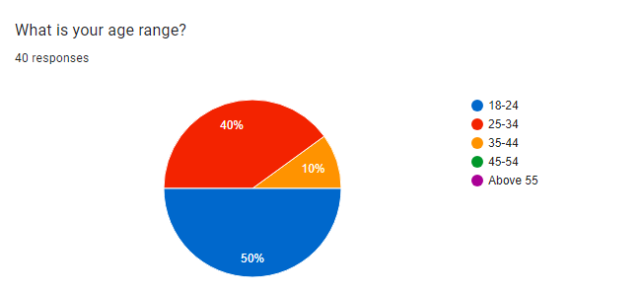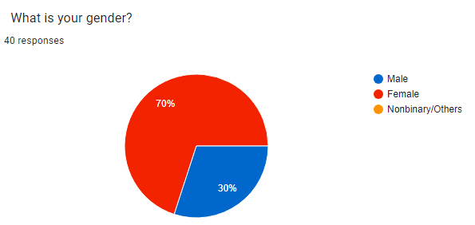

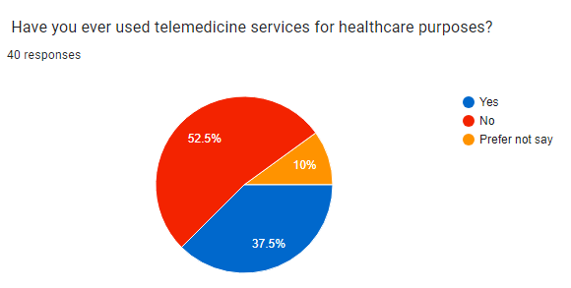

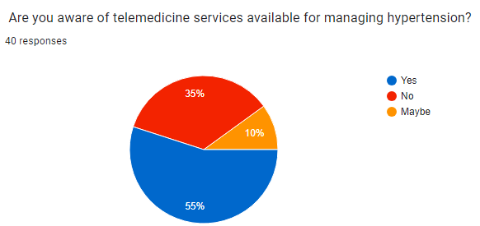

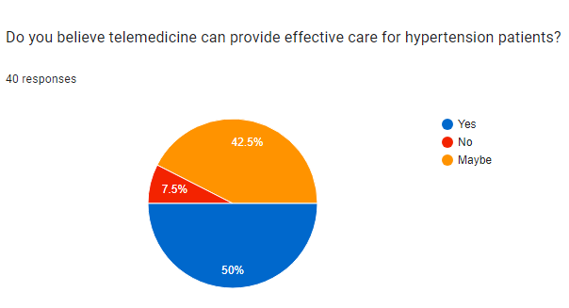

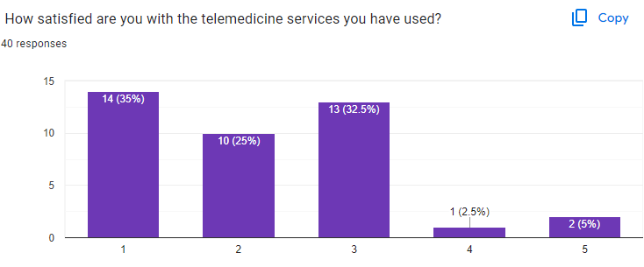

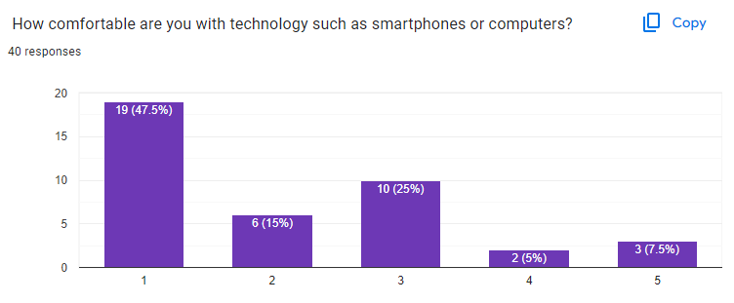

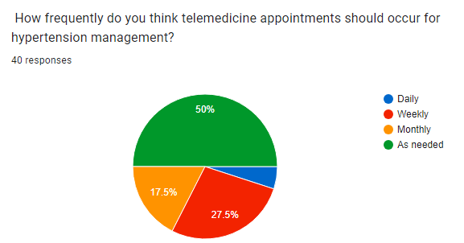

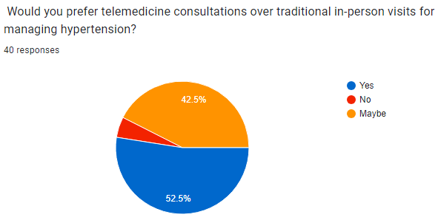

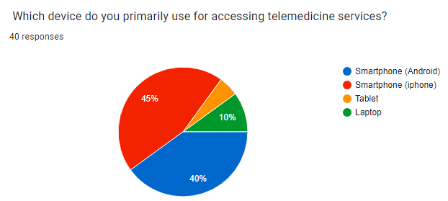

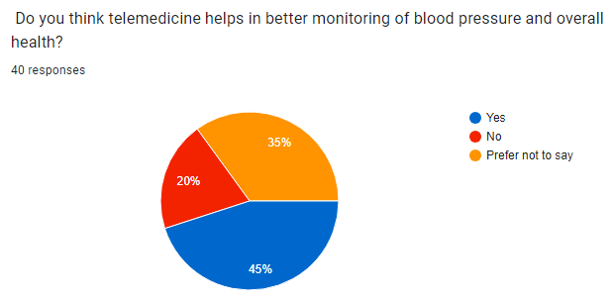

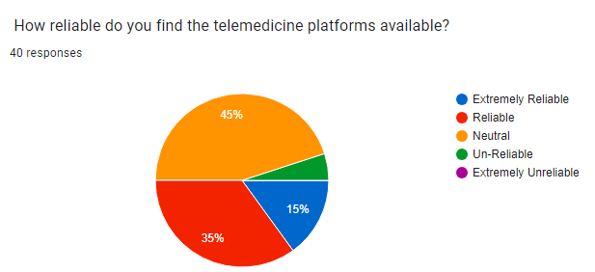

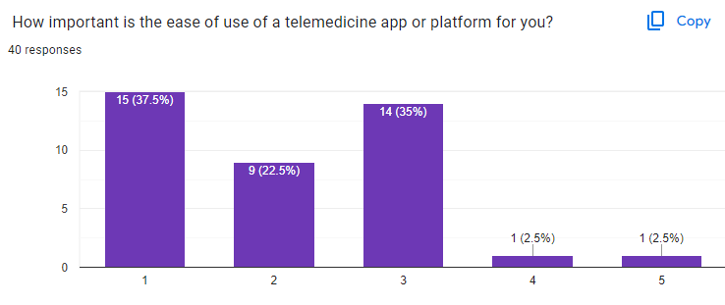

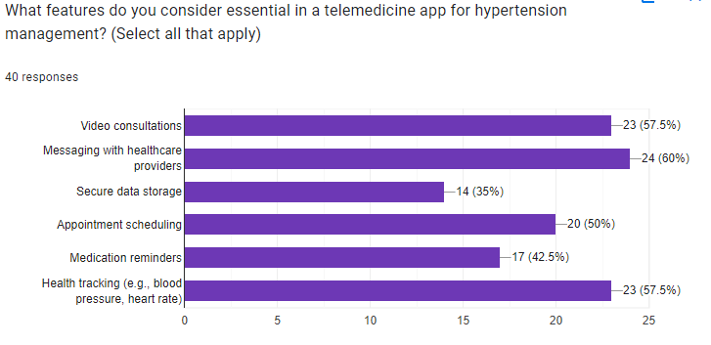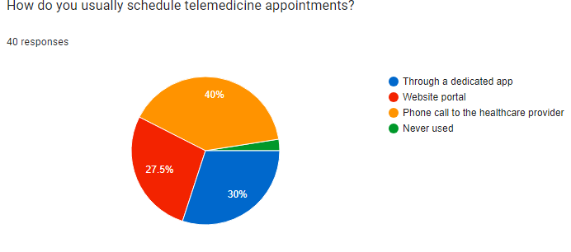

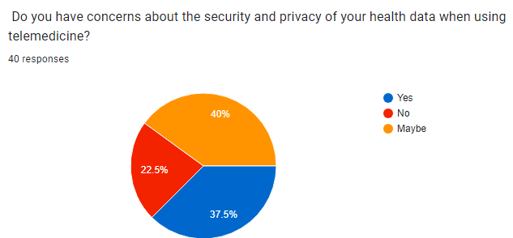

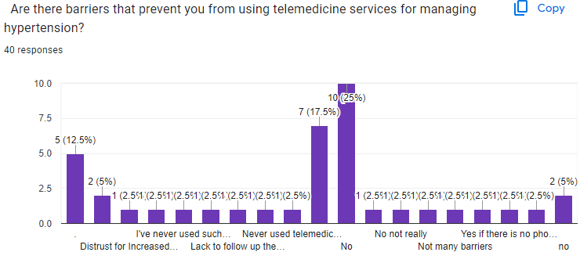

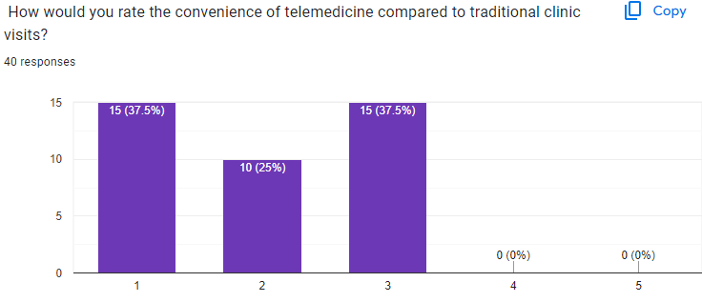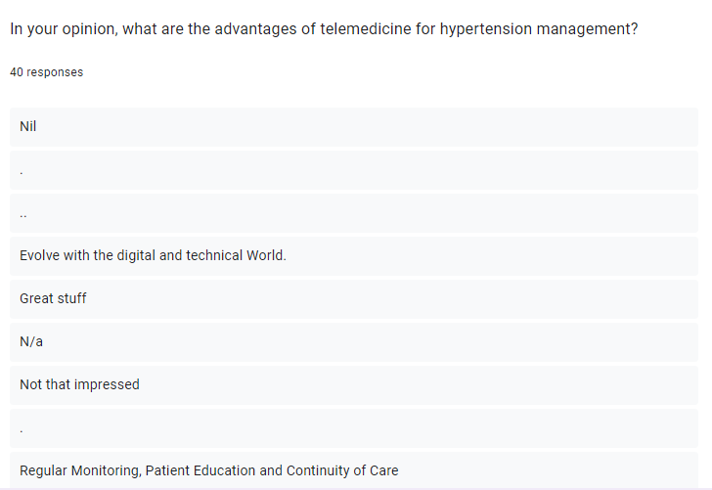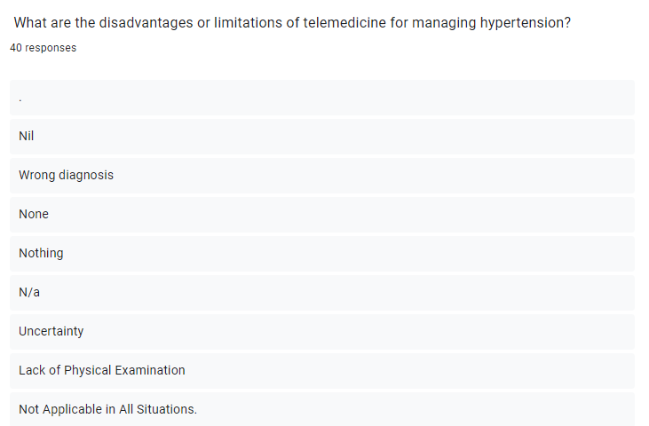

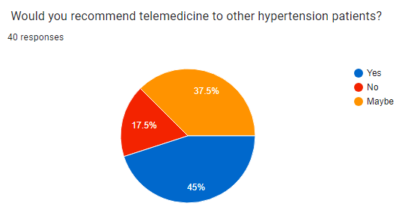

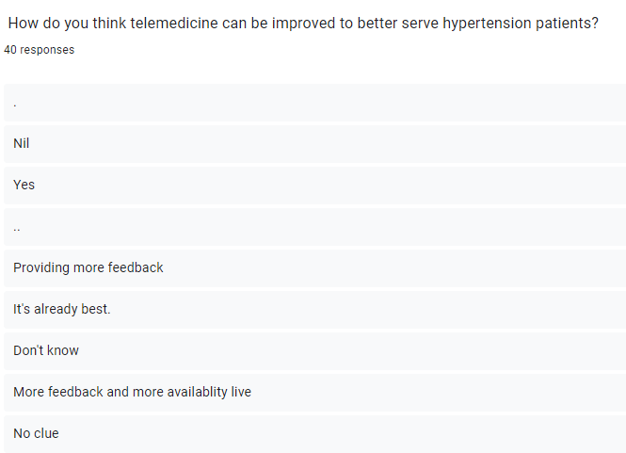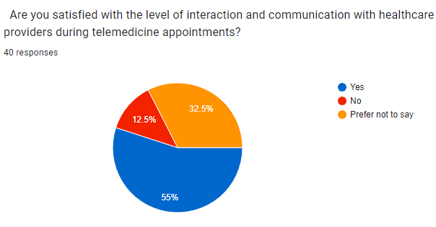

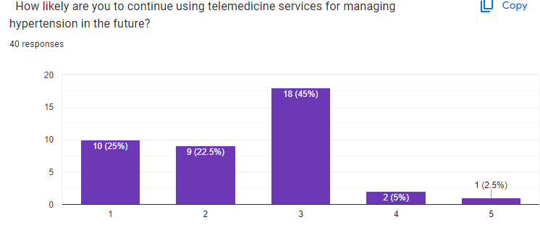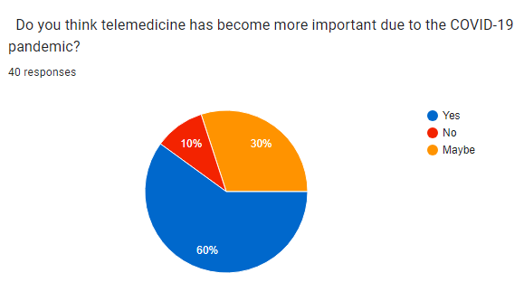

**CONCLUSION**

The business plan is positioned for successfulness as evidence is provided by extensive marketplace research with positive feedback from potential consumers. This new approach to hypertension management through telemedicine could offer quite a lot of potential prospects. Having a well-defined strategy with good financial plan, this business has a likelihood of being successful and expanding into a larger unit of healthcare services. We believe in our capacity to acquire all our objectives. A demonstration of telemedicine has been given as below:

